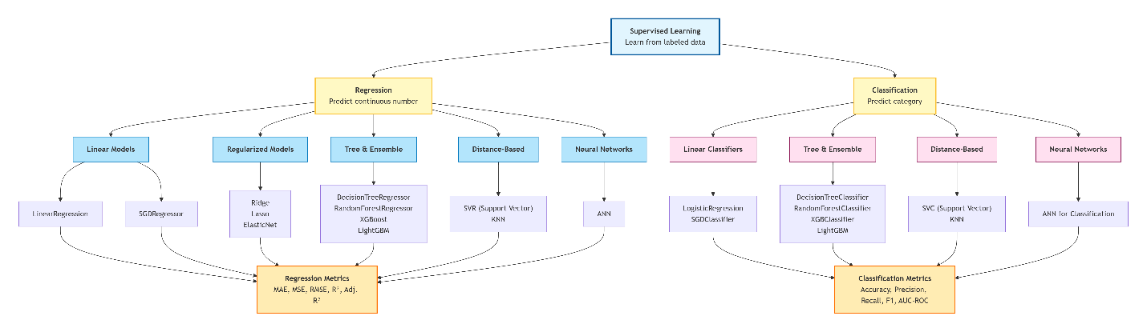
Supervised Classification is a type of supervised machine learning where the target variable (dependent variable) is discrete – meaning it belongs to a finite set of categories or classes. Instead of predicting a continuous number (as in regression), the model predicts a category label.
Examples:
- Spam or not spam (binary)
- Type of flower (multi-class)
- Tags for an image (multi-label)
Key idea: The model learns a decision boundary that separates different classes based on the input features. It then assigns new, unseen data points to one of the predefined classes.
Classification Evaluation Metrics
To know how well a classification model performs, we use a set of metrics that compare its predictions against the true labels. The most fundamental tool is the confusion matrix.
1. The Confusion Matrix – The Foundation
The confusion matrix is a table that summarizes the performance of a classification model. For binary classification:
 | Predicted Positive | Predicted Negative
Actual Positive | True Positive (TP) | False Negative (FN)
Actual Negative | False Positive (FP) | True Negative (TN)
- TP: Correctly predicted positives.
- TN: Correctly predicted negatives.
- FP: Predicted positive but actually negative (Type I error).
- FN: Predicted negative but actually positive (Type II error).
2. Accuracy – Overall Correctness
$$\text{Accuracy}=\frac{TP+TN}{TP+TN+FP+FN}$$
Interpretation:
The proportion of total predictions that are correct.
- Range: 0 to 1 (or 0% to 100%).
- Caution: Can be misleading when classes are imbalanced.
Example:
If TP = 80, FN = 20, FP = 10, TN = 90:
$$\text{Accuracy}=\frac{80+90}{80+90+10+20}=\frac{170}{200}=0.85 (85\%)$$
Python:
from sklearn.metrics import accuracy_score
y_true = [1, 0, 1, 1, 0, 1]
y_pred = [1, 0, 0, 1, 0, 1]
accuracy = accuracy_score(y_true, y_pred)
print(accuracy) # 0.833...
3. Precision – Reliability of Positive Predictions
$$\text{Precision}=\frac{TP}{TP+FP}$$
Interpretation:
Of all instances predicted as positive, how many were actually positive?
- High precision means few false positives.
- Use when false positives are costly (e.g., spam filter marking important email as spam).
Example:
From above:
$$\text{Precision}=\frac{80}{80+10}=0.889 (88.9\%)$$
Python:
from sklearn.metrics import precision_score
precision = precision_score(y_true, y_pred)
print(precision) # 0.8
4. Recall (Sensitivity / True Positive Rate)
$$\text{Recall}=\frac{TP}{TP+FN}$$
Interpretation:
Of all actual positives, how many did we correctly identify?
- High recall means few false negatives.
- Use when missing a positive is costly (e.g., disease detection).
Example:
$$\text{Recall}=\frac{80}{80+20}=0.80 (80\%)$$
Python:
from sklearn.metrics import recall_score
recall = recall_score(y_true, y_pred)
print(recall) # 0.667 (example depends)
5. Specificity (True Negative Rate)
$$\text{Specificity}=\frac{TN}{TN+FP}$$
Interpretation:
Of all actual negatives, how many did we correctly identify?
- High specificity means few false positives.
- Important in fields like fraud detection or medical screening where false alarms cause unnecessary stress/cost.
Example:
$$\text{Specificity}=\frac{90}{90+10}=0.90 (90\%)$$
Python: (Scikit-learn doesn't have a direct function, but compute from confusion matrix)
from sklearn.metrics import confusion_matrix
cm = confusion_matrix(y_true, y_pred)
TN, FP, FN, TP = cm.ravel() # careful: order may vary, use cm.ravel() after checking
specificity = TN / (TN + FP)
print(specificity)
6. F1-Score – Harmonic Mean of Precision and Recall
$$F1=2×\frac{\text{Precision}×\text{Recall}}{\text{Precision}+\text{Recall}}$$
Interpretation:
Balances precision and recall. Good single metric when classes are imbalanced and both FP and FN are important.
Example:
Using precision = 0.889, recall = 0.80:
$$F1=2×\frac{0.889×0.80}{0.889+0.80}=2×\frac{0.7112}{1.689}≈0.842$$
Python:
from sklearn.metrics import f1_score
f1 = f1_score(y_true, y_pred)
print(f1) # 0.727
7. ROC Curve & AUC
- ROC (Receiver Operating Characteristic) curve: Plots True Positive Rate (Recall) against False Positive Rate (1 – Specificity) at all possible thresholds.
- AUC (Area Under the Curve): The area under the ROC curve – a single number summarising model performance across thresholds.
Interpretation:
- AUC = 1 → perfect classifier
- AUC = 0.5 → random guessing
- AUC < 0.5 → worse than random (but can be inverted)
Why AUC?
- Threshold-independent.
- Works well for imbalanced datasets.
- Good for comparing models.
Python:
from sklearn.metrics import roc_auc_score, roc_curve
import matplotlib.pyplot as plt

y_true = [0, 0, 1, 1]
y_scores = [0.1, 0.4, 0.35, 0.8]

auc = roc_auc_score(y_true, y_scores)
print(f"AUC: {auc:.2f}") # 0.75

fpr, tpr, _ = roc_curve(y_true, y_scores)
plt.plot(fpr, tpr, label=f'AUC = {auc:.2f}')
plt.plot([0,1], [0,1], 'k--')
plt.xlabel('False Positive Rate')
plt.ylabel('True Positive Rate')
plt.legend()
plt.show()
8. When to Use Which Metric?
Metric | Best Used When...
Accuracy | Classes are balanced; all errors cost the same.
Precision | False positives are costly (e.g., spam detection, innocent flagged as guilty).
Recall | False negatives are costly (e.g., disease screening, fraud detection).
Specificity | False positives are costly (e.g., confirmatory testing, unnecessary treatment).
F1-Score | You need a balance; class imbalance; both FP and FN matter.
AUC-ROC | Want a threshold-free measure; compare models; imbalanced data.
Log Loss | Need to evaluate probability predictions (confidence).
Python Code – Complete Example
python
from sklearn.metrics import confusion_matrix, accuracy_score, precision_score, recall_score, f1_score, roc_auc_score

# Example data (binary classification)
y_true = [1, 0, 1, 1, 0, 1, 0, 0, 1, 0]
y_pred = [1, 0, 1, 0, 0, 1, 0, 1, 1, 0]

# Confusion matrix
cm = confusion_matrix(y_true, y_pred)
print("Confusion Matrix:\n", cm)

# Metrics
accuracy = accuracy_score(y_true, y_pred)
precision = precision_score(y_true, y_pred)
recall = recall_score(y_true, y_pred)
f1 = f1_score(y_true, y_pred)

print(f"Accuracy: {accuracy:.2f}")
print(f"Precision: {precision:.2f}")
print(f"Recall: {recall:.2f}")
print(f"F1 Score: {f1:.2f}")

# For AUC, we need predicted probabilities
y_scores = [0.9, 0.2, 0.8, 0.4, 0.3, 0.7, 0.1, 0.6, 0.85, 0.2]
auc = roc_auc_score(y_true, y_scores)
print(f"AUC: {auc:.2f}")

Summary Table
Metric | Formula | Range | Interpretation
Accuracy | (TP+TN)/(TP+TN+FP+FN) | [0,1] | Overall correctness
Precision | TP/(TP+FP) | [0,1] | Of predicted positives, how many are true?
Recall | TP/(TP+FN) | [0,1] | Of true positives, how many captured?
Specificity | TN/(TN+FP) | [0,1] | Of true negatives, how many captured?
F1-Score | 2×(P×R)/(P+R) | [0,1] | Harmonic mean of precision & recall
AUC | Area under ROC curve | [0,1] | Overall classifier quality (threshold-free)

